Hands-On Lab for 9.0 Deep Dive

About this Data
The Las Vegas Yelp Data.xls data set is from Yelp, and shows information about Businesses, Reviews, and Users through 2014. It is filtered for the City of Las Vegas, for the years 2011 – 2014, and for Business Categories in Bars Cafes and Restaurants (this field was simplified).

The Las Vegas Loyalty Data.xls data set contains fabricated data representing customer purchase patterns for a Loyalty program. It is intentionally messy in order to demonstrate data prep features like Data Interpreter and Pivot.

Both of these data sets are in Excel files so that attendees can see and easily understand the data prep process. Note that the Excel files are blended (instead of joined) in order to demonstrate pivot on the secondary data source.

Agenda
- Connect to Data
- Analytics
- Data Prep
- Calculations and LOD Expressions
- LOD Expressions – Optional Example 2

Format of the Training
  - Each section has a guiding statement or question
Overview:
Provides basic directions on the purpose of the section and what the desired outcome is. For those who want to dive in and try it on their own, this may be enough guidance to begin.
Detailed Steps:
Provides step-by-step level directions on how to complete the section.

0) Connect to Data
  - Connect to an Excel file and join two tables
Overview:
Open the file “Las Vegas Yelp Data”
Detailed Steps:
- Open Tableau Desktop 9.0
- Under “Connect” Click “Excel”
- Navigate to the file on your machine (desktop) and open it
- Click and drag out the sheet named Las Vegas Yelp Data
- Click “Sheet 1” and call it “Reviews vs. Ratings”

1) Analytics
  - I am a Las Vegas event planner. Tableau is coming for Tableau Conference 2015. Where should I recommend that they eat?
Overview:
- Drag and Drop Analytics
  - Create a Scatter Plot of Business Name comparing Average Stars to Number of Records
  - Drag out Analytics items from the Analytics Pane to learn about the data
- Instant Analytics
  - Color by Business Category
  - Click each in the legend to see instant analytics
Detailed Steps:
How do my restaurants look compared to others in their category, in terms of ratings?
- Create Scatter Plot
  - Drag Stars to Rows Shelf
    - Double click on Pill, change from SUM to AVG
  - Drag Number of Records to Columns Shelf
  - Drag Business Name to Detail
- Drag and Drop Analytics
  - Open Analytics Pane
  - Drag Trend Line into view
    - Choose “Linear”
    - Hover over the trend line to see the value
  - Drag Trend Line off of view
  - Drag Average Line into view
    - Choose “Table”
    - Hover to see value of vertical line
    - Drag vertical line off
    - Hover to see value of horizontal line
      - Click on the Average Line
      - Options appear above the Tooltip
      - Click the caret by Average and change it to Median
    - Click Edit on Tooltip
      - Set back to Average
      - Set Label to Value
- Drag Business Category to Color
- Click on Café’s to see Instant Analytics
- Name Worksheet “Reviews vs. Ratings”

2) Data Prep
  - Bring in a data set that does not have data in columns
Overview:
- Connect to Las Vegas Loyalty Data.xls and prepare the data
- See Customer growth over time, by Business Name
- Create a Dashboard to use the Scatter Plot as a filter
Detailed Steps:
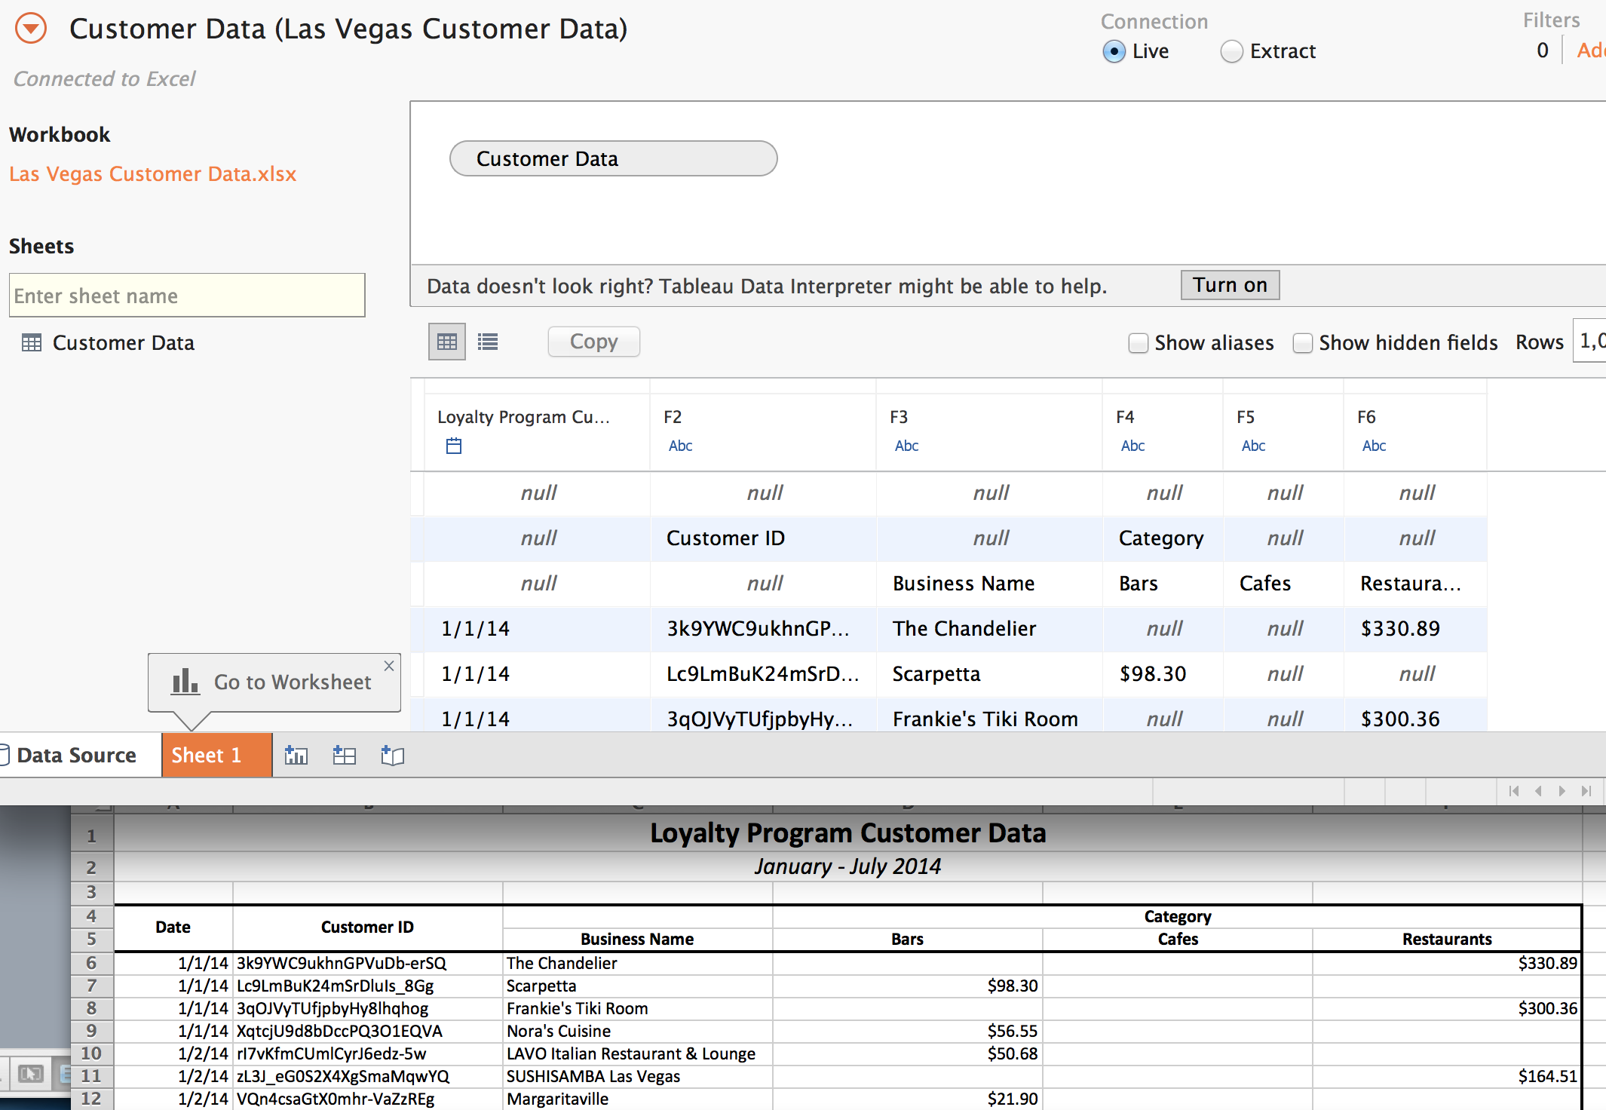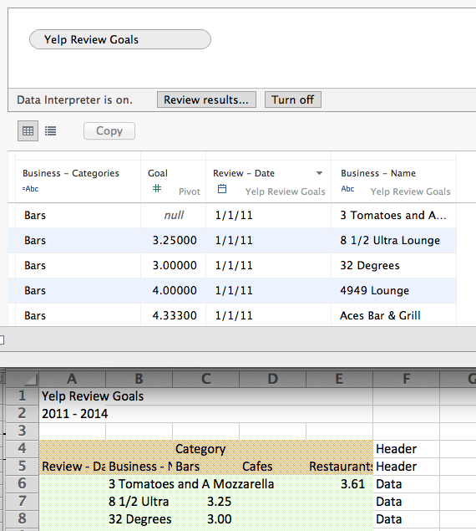
- Click the Tableau Icon
  - Click Excel to connect to a new dataset
  - Navigate to Las Vegas Loyalty Data.xls
- Show Data Interpreter
  - Click “Turn On”
  - Optional: Click “Review Results’ to see what the Data Interpreter has done
- Pivot
  - Select the 3 Category fields (on a Mac, by dragging across them. On a PC, hold down shift and click on the first and last columns).
  - Choose Pivot from caret drop down
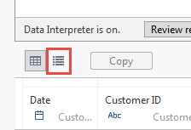
- Split
  - Select just the new “Pivot field names” column
  - Choose Split from caret drop down
- Go to Metadata Grid (image to the right)
  - Single-click on “Pivot field names – Spilt 1”
  - Rename it “Business Category”
  - Press Tab to move to the next field
  - Rename it “Spend”

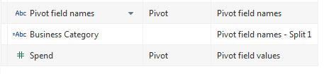

Graph New Customer Acquisition Over Time. Which business is the fastest growing?
- Create a new Tab called Customer Growth
  - Double click on Rows Shelf
  - Type COUNT(Customer ID) and click tab
  - Drag Date to Columns
    - Click caret on Date
    - Choose Exact Date
  - Create a Quick Table Calc for User ID
    - Click Caret on Customer ID Pill
    - Choose Running Total
  - Drag Business Name onto Color

Create a Dashboard to filter the view using the Scatter Plot

- Create Dashboard: “Las Vegas Restaurants”
- Drag Reviews vs. Ratings into view
- Drag Customer Growth below it
- Click Caret on Reviews vs. Ratings, choose “Use as Filter”
- Right click on view > “Show View Toolbar”
- Choose Lasso Select option
  - Select the 4 dots that are the farthest right and above average

3) Calculations and Level of Detail Expressions
  - What businesses are driving signups to the Loyalty program?
Overview:
- Identify New Customers
  - Create a Level of Detail Expression of the date of each User’s first review
  - Create a calculation to identify the date for which they were new customers
- Add to filter for Customer Growth
Detailed Steps:
Identify New Customers

- Create new sheet called “LOD Prep”
- Drag Customer ID to Rows Shelf
- Double click to the right of Customer ID on the Rows Shelf, start to type Date, let Tableau auto-complete
- Create a new Calculation
  - Title it “Date of Customer’s First Visit”
  - Type “MI” and let Tableau auto-complete
  - Drag Date into Calc
  - Close Parentheses and click Apply
  - Double Click to the right of Date on the Rows Shelf
    - Type “[Date of” and let Tableau auto complete
    - See that the MIN is calculating at the level of detail in the view
    - Drag it off
  - In the Calc editor, type around your text so it says: { fixed[Customer ID] : MIN([Date]) }
  - Click Apply
  - Double Click to the right of Date on the Rows Shelf
    - Type “[Date of” and let Tableau auto complete
- Double click on Marks Card to start new Calculation
  - Drag Date into the pill
  - Type “=”
  - Drag Date of Customer’s First Visit into the pill
  - Click Enter
  - Set to Color
  - Drag this pill from the Marks Card to Dimensions
  - Name it “New Customer”

Add filter to Customer Growth graph

- Go to Customer Growth tab
  - Drag New Customer onto Filters shelf

4) Level of Detail Expressions – Optional Example 2
What is the distribution of restaurants over their average reviews? Use the Las Vegas Yelp Data (not the loyalty data)
- Create a New Sheet called Aggregate Bins
- Create a new Calculation
  - Title it “Average Review by Business”
  - Type “{ Fixed[Business Name] : AVG([Stars]) }”
  - Click Apply
- Right click on new field > Create > Bins
  - Set to .2
- Double click on Rows Shelf
  - Type COUNT([Number of Records)}
  - Double click on Average Review by Business (bin)

