Tableau Pulse Series: Hands-On Prep Builder for Healthcare and Life Sciences

Tableau Prep Builder helps analysts and business users get data ready for analysis
- Prep makes data preparation visual and direct just like building a viz
- Prep has smart defaults, so users don’t have to do repetitive tasks
- Prep is tightly integrated with Tableau so users can quickly analyze data

Tableau Prep Conductor lets users schedule and run Prep flows in a scalable, reliable, and secure environment. Customers can centralize the scheduling, monitoring, and administration of data preparation performed in Tableau Prep.

Hands-On Instructions

Open Tableau Prep and have your 3 .csv files readily available:  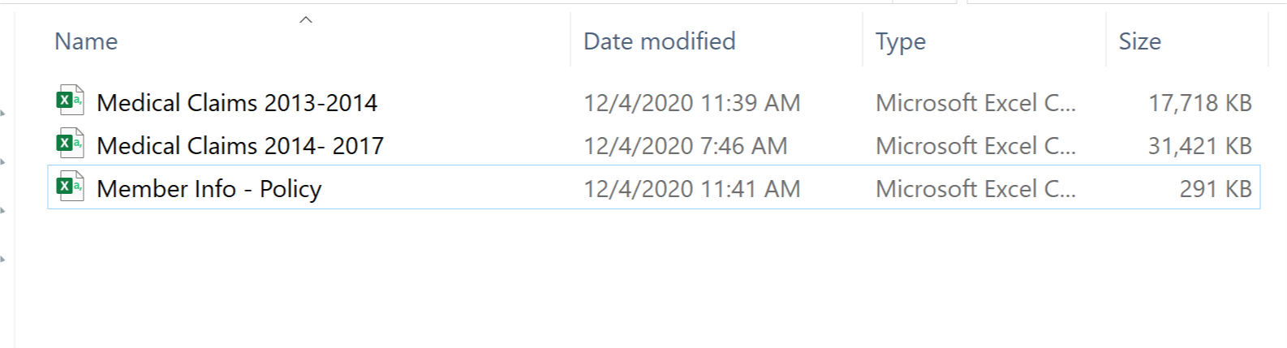 | Today we will get hands on with Tableau Prep Builder and Conductor.  We will be covering four main topics:  - How to connect to data in Prep Builder  - How to combine and integrate multiple data sets through joins and unions  - How we can interact with and clean data  - And finally, share and refresh the data on Tableau Server.  We first need to clean and join 3 Medical Billing files.
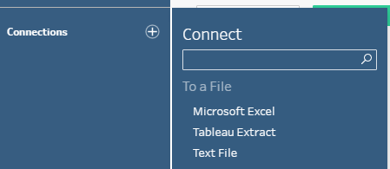  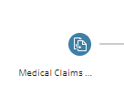 | CONNECTING TO DATA:  - Click on the Add Connection button  - Show flat file connections and server options  Connect to Data  - Select Text File under To a File  - Open Medical Claims 2013-2014.csv  - Add a Clean Step
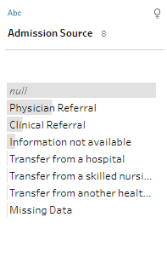  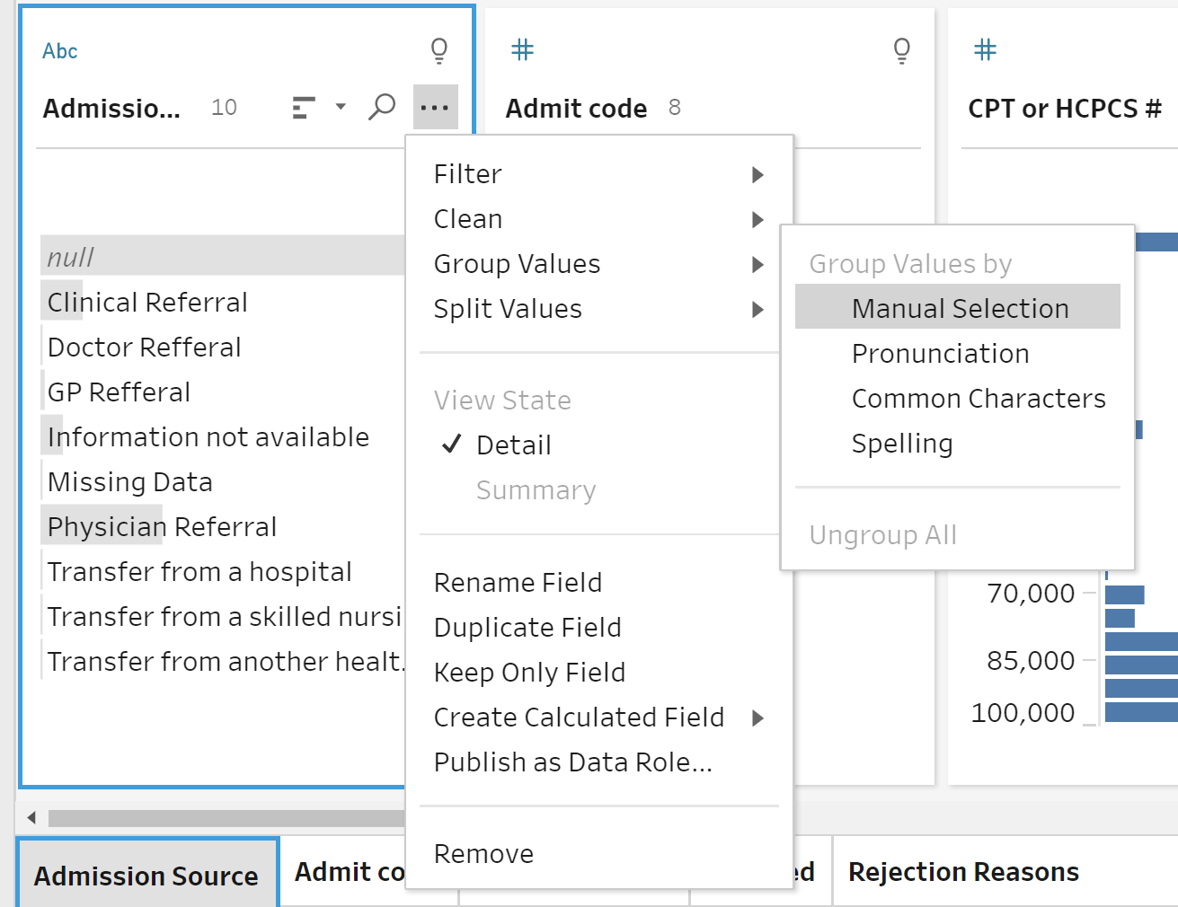  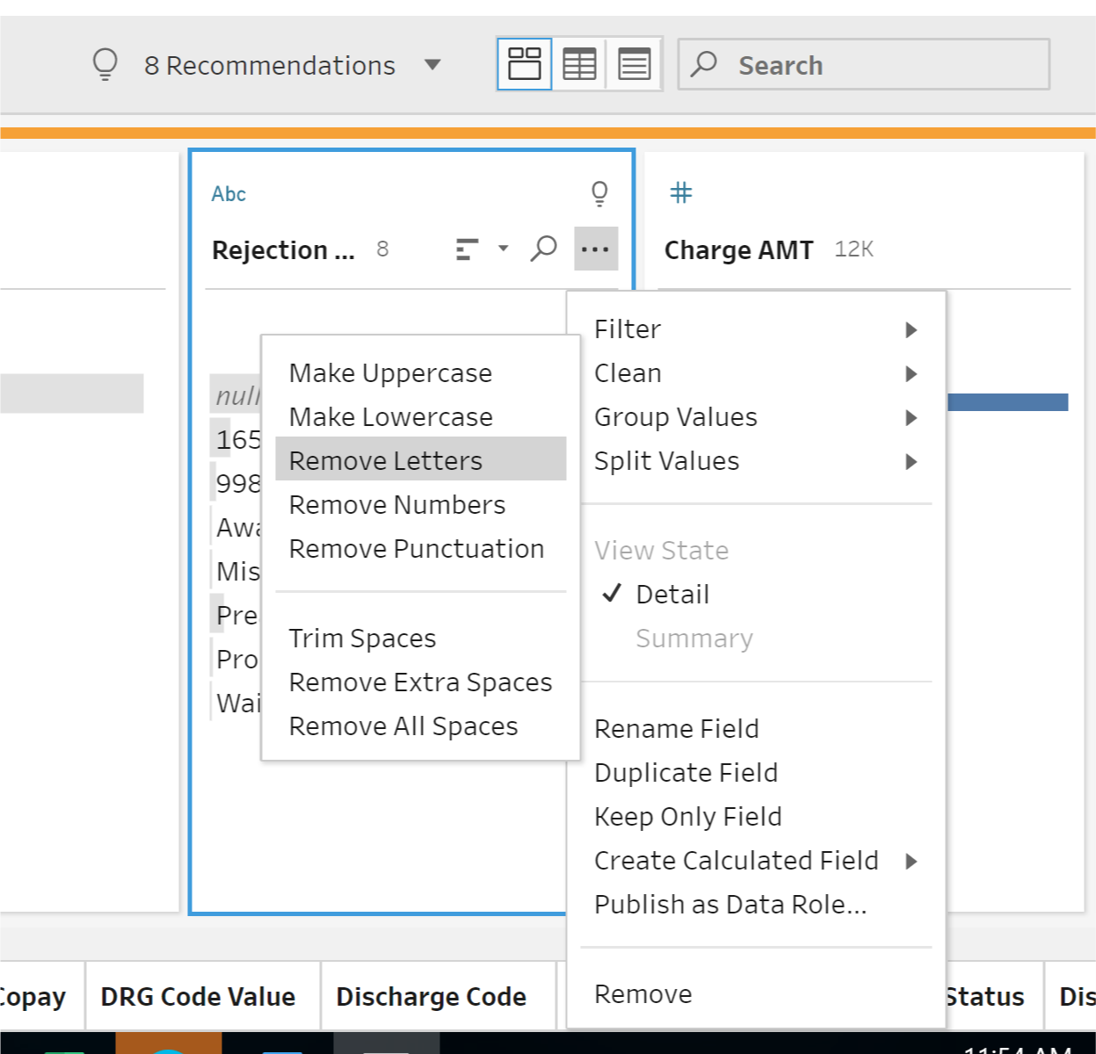  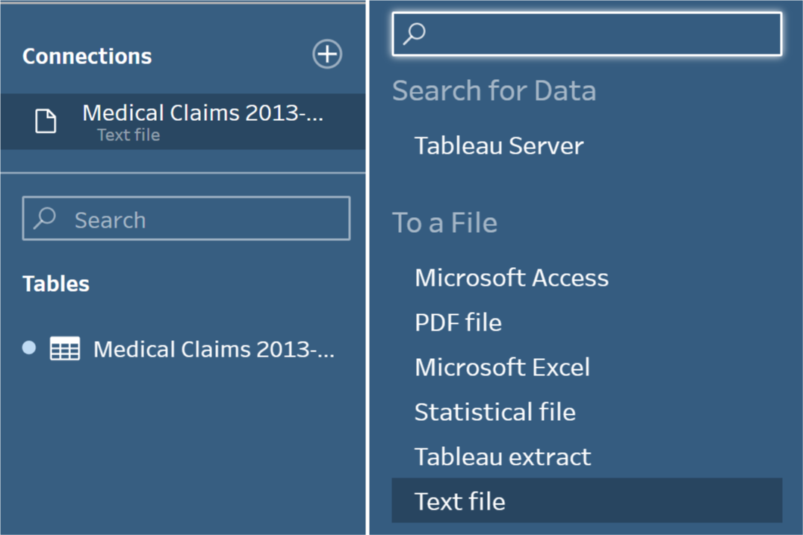  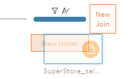 | Clean Medical Claims #1:  Under each Profile – or column of data – is a bar chart. These small visualizations are based off the number of rows for each value and help me identify trends.  - Note the Profile pane (columns of data)  - Bar chart – see many rows a value is made up of.  Clean Admission Source  - Find 3 ellipses -> Group Values -> Manual Selection  - Select Physician Referral and also check ‘Doctor Refferral’ and ‘GP Refferal’  - Note ‘Refferal’ is spelled wrong but that’s OK the grouping takes care of that.  - Do the same Grouping for ‘Missing Information’ and ‘Information Not Available’  Clean Rejection Reasons:  - Find ellipses Clean-> Remove Letters  Double Click on step where it says Clean 1, rename to Medical Claims ’13-14 Clean  Integrate second Medical Claims 2014-2017 csv  - Find + to add a new file, choose Text File and find this second file  - These files need to be Unioned as they are the same data, just different years.  - Hold and drag the second file on top of your cleaned Medical Claims 2013-2014
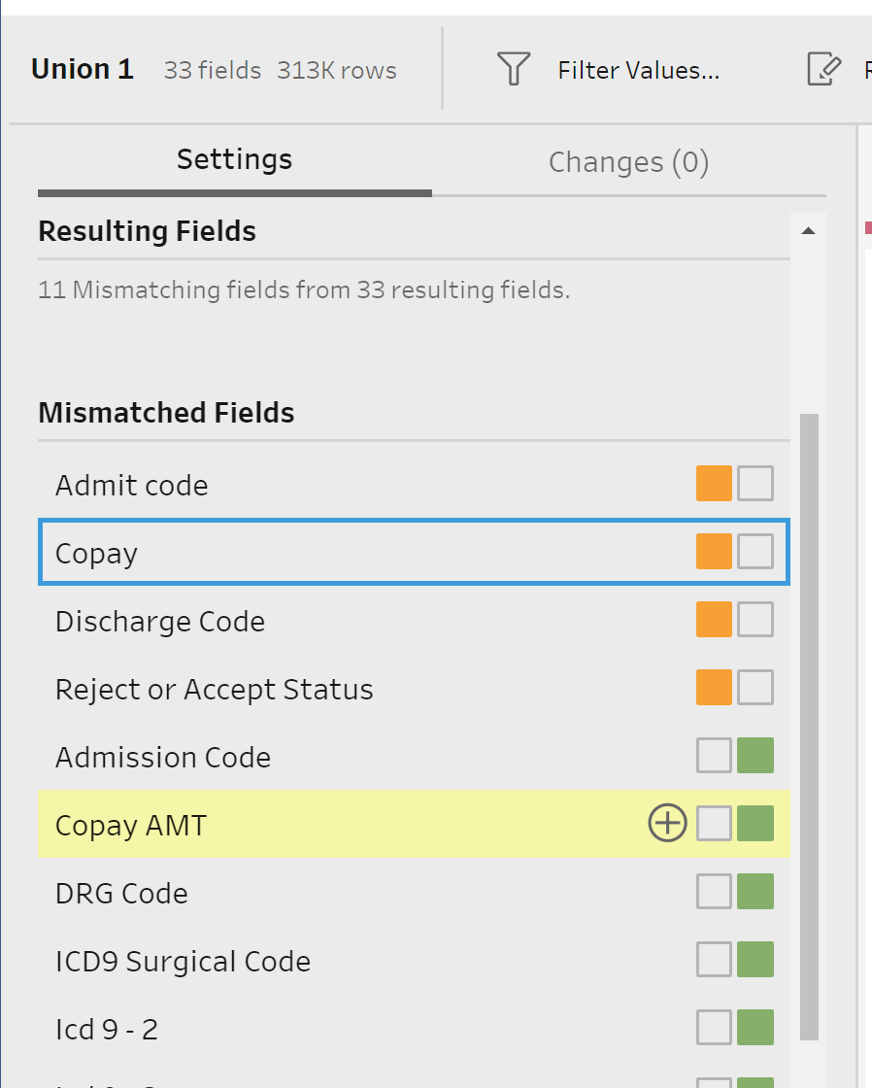 | Fix Mismatched Fields:  There are a few columns of data in each dataset that have the same values but are named differently. We can simply selected fields and Tableau will show us the corresponding match.  - Fix mismatched fields for Copay, Admit Code, Discharge Code & Reject or Accept
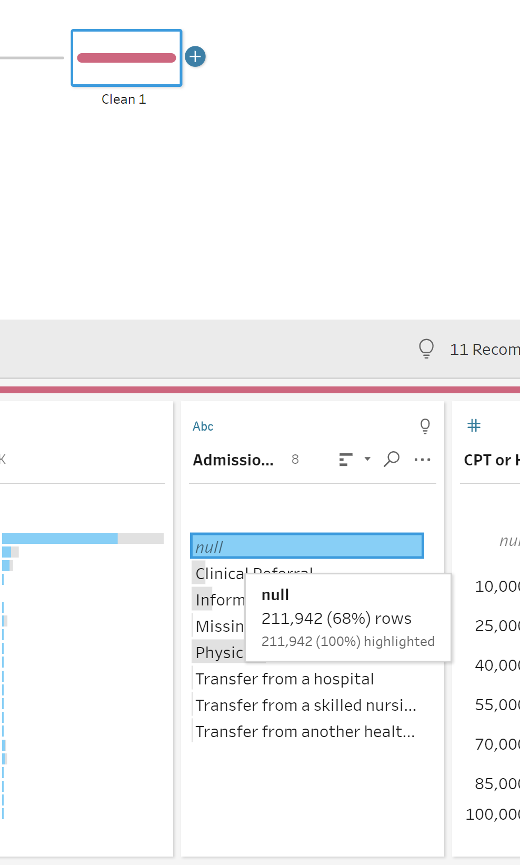  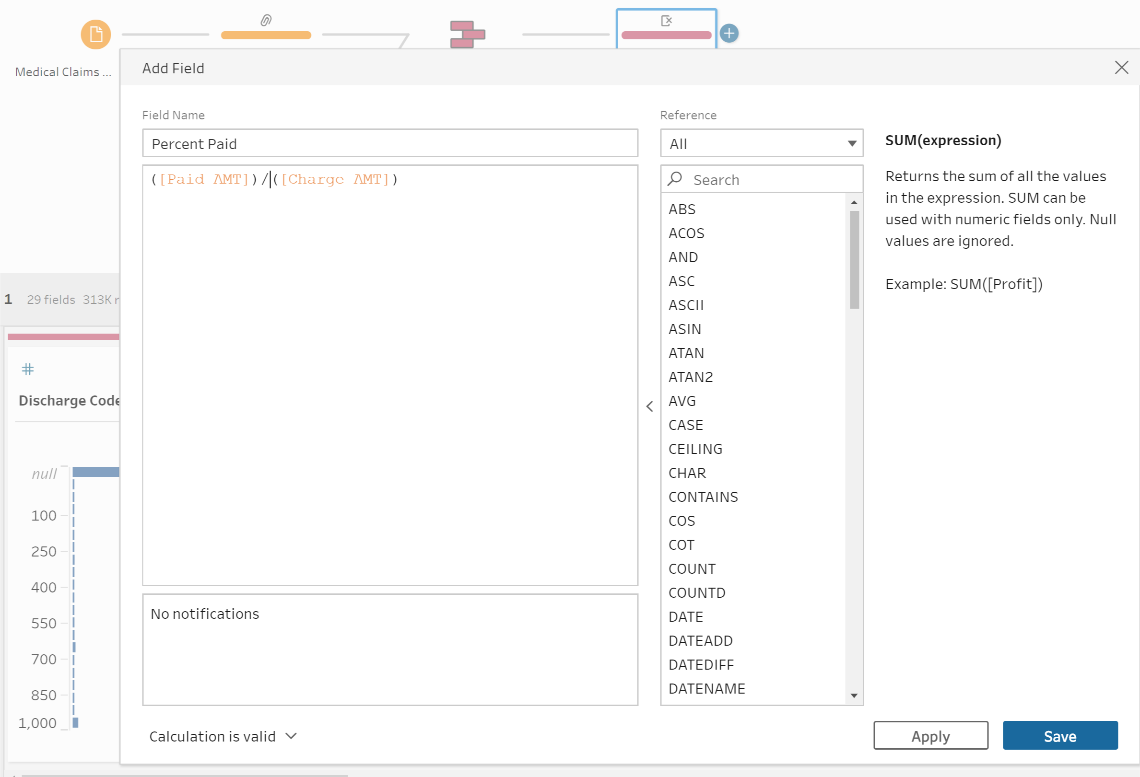 | Cleaning the Union  Now that we have our fields merged, let’s clean up our dataset.  - Add a Clean Step  - Find Admission Source -> click right into Nulls and replace with “Not Applicable”  - Remove column: ‘Table Name’  - Create a New Calculation: Percent Paid  ([Paid AMT])/ ([Charge AMT])
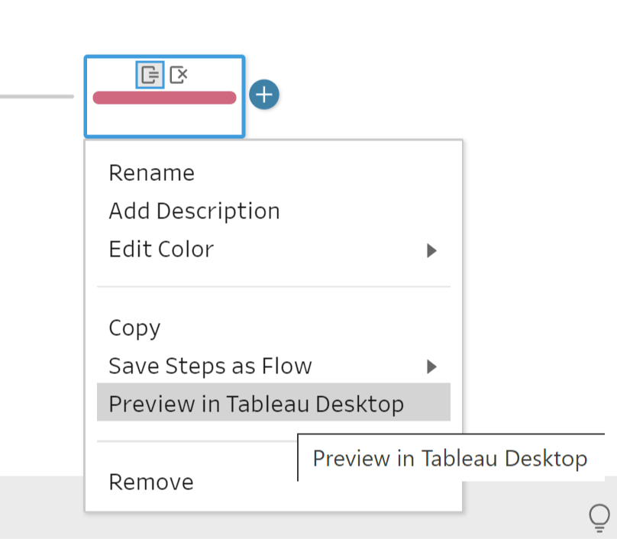  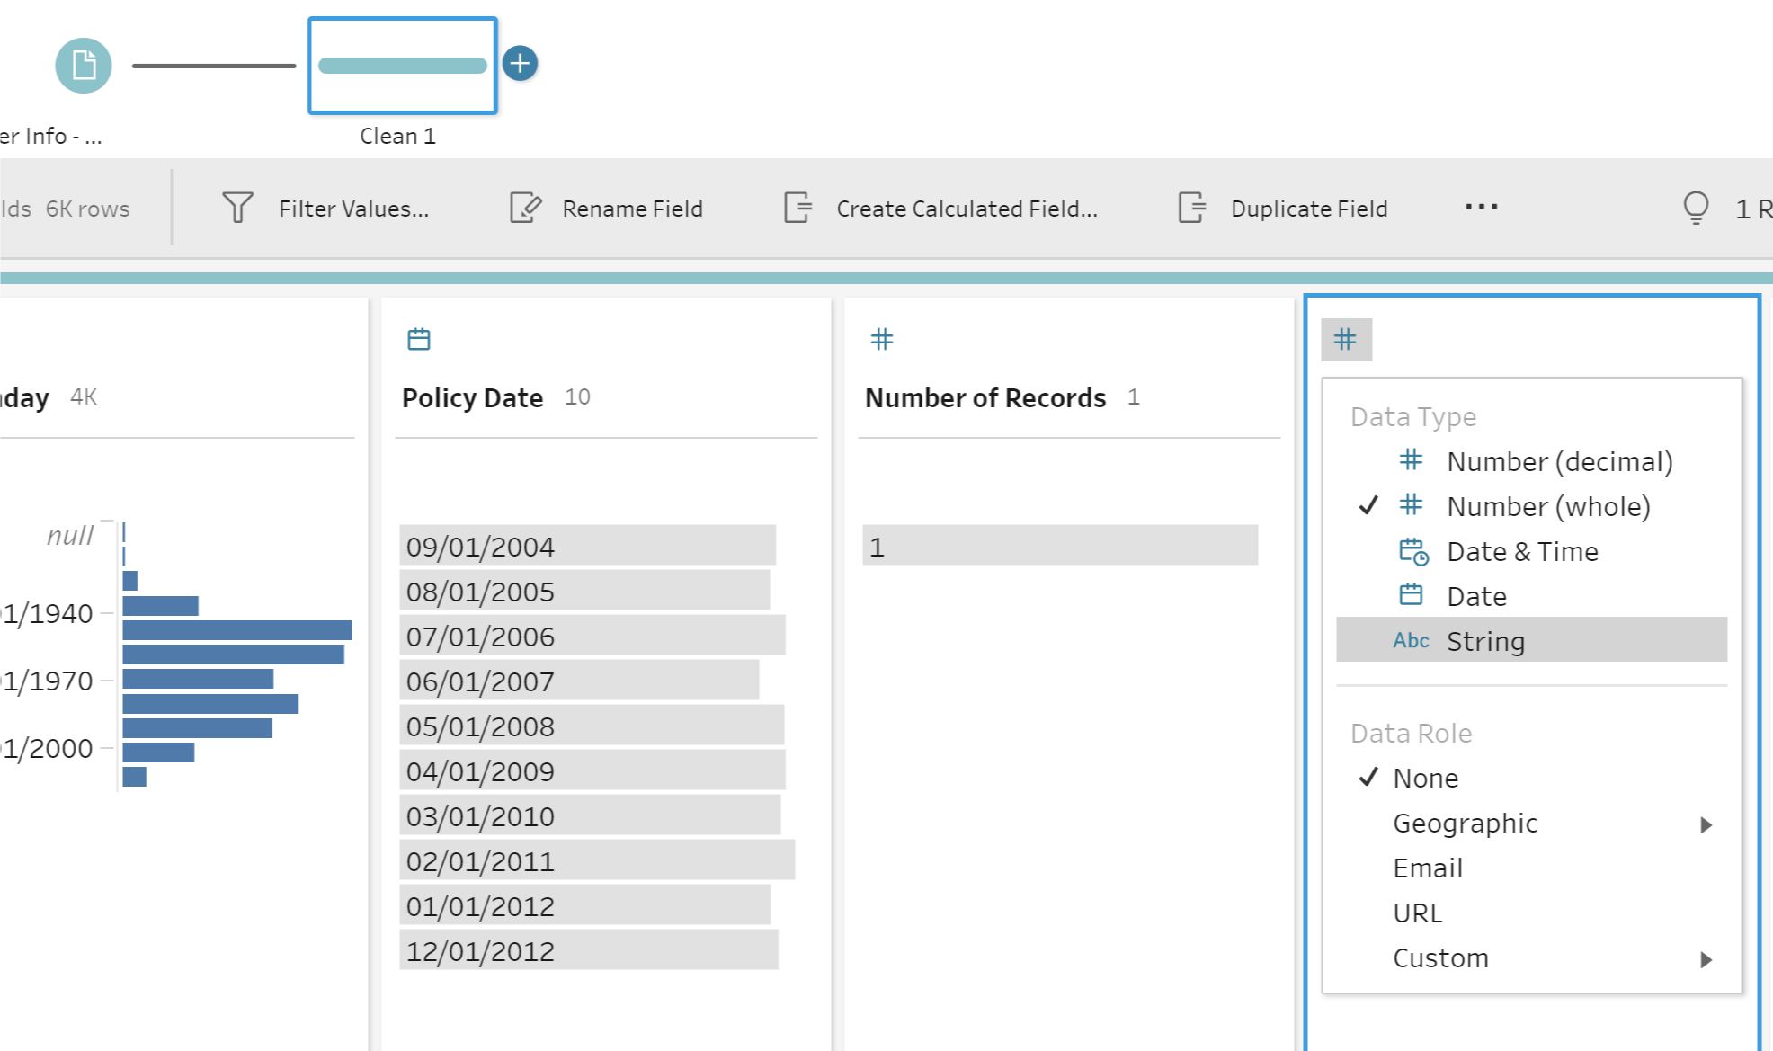  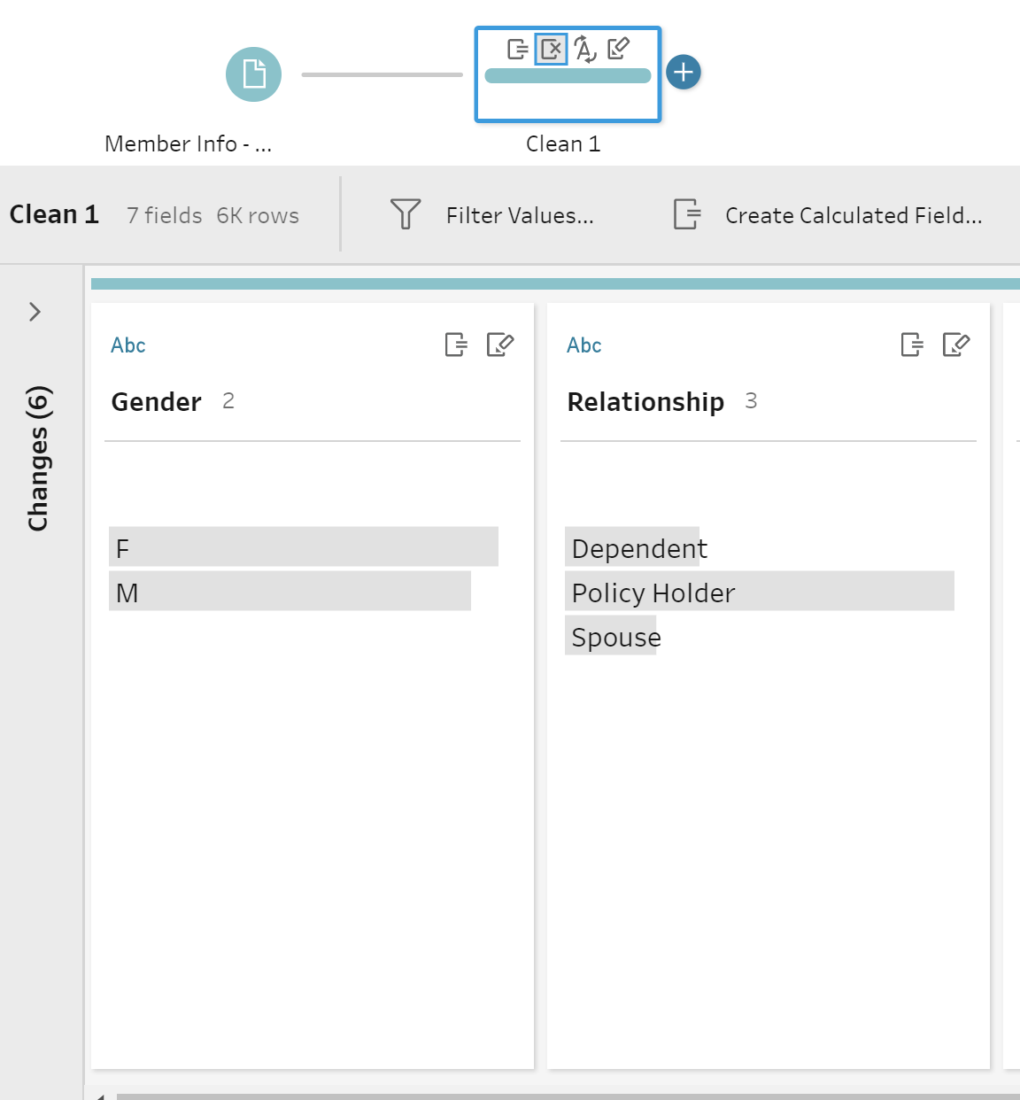 | Let’s take a moment and check our work so far. Right click on your latest Clean step and choose Preview in Tableau Desktop  Clean Member Policy File:  Now that we’ve cleaned up the Claims data we need to integrate our Policy Data.  - Add Connection-> Text File -> Member Info – Policy  Add a Clean Step:  - Change Patient ID to STR  - Split Patient Desc field -> Ellipses -> Automatic Split  - Rename New Fields to Gender and Relationship  - Remove Parent field Patient Desc  Rename Step to Member Info Clean
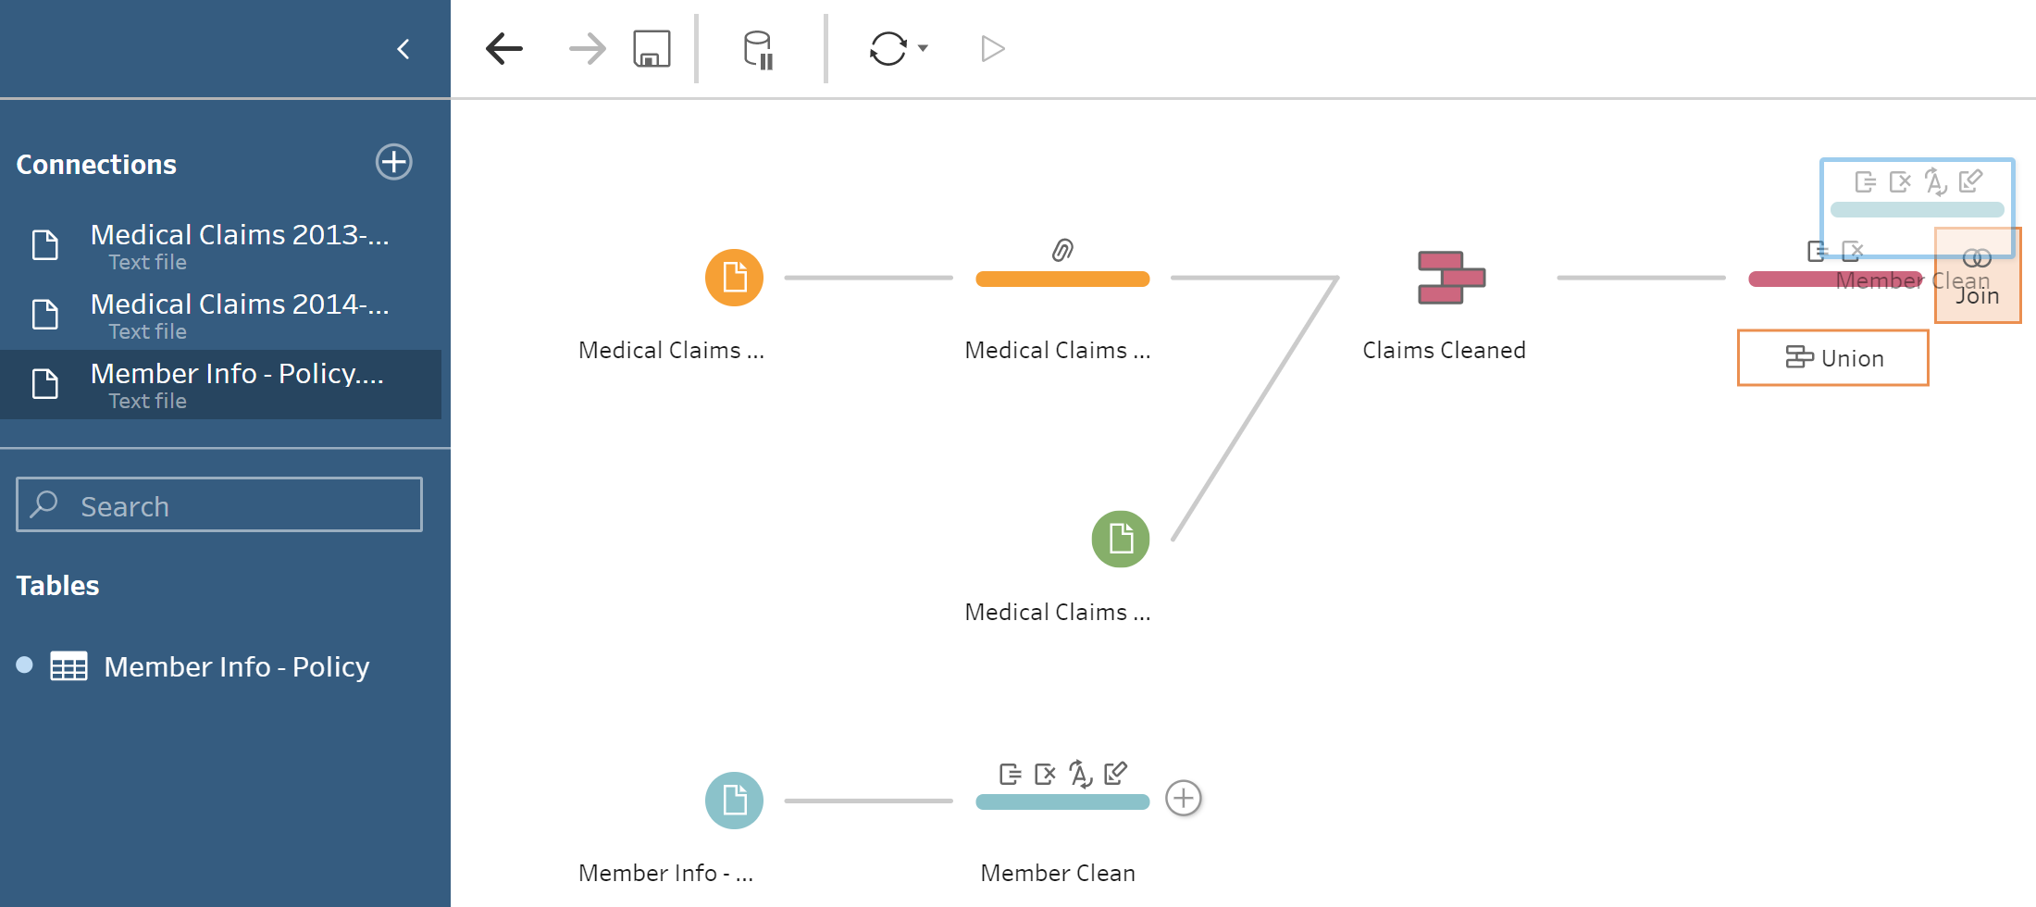  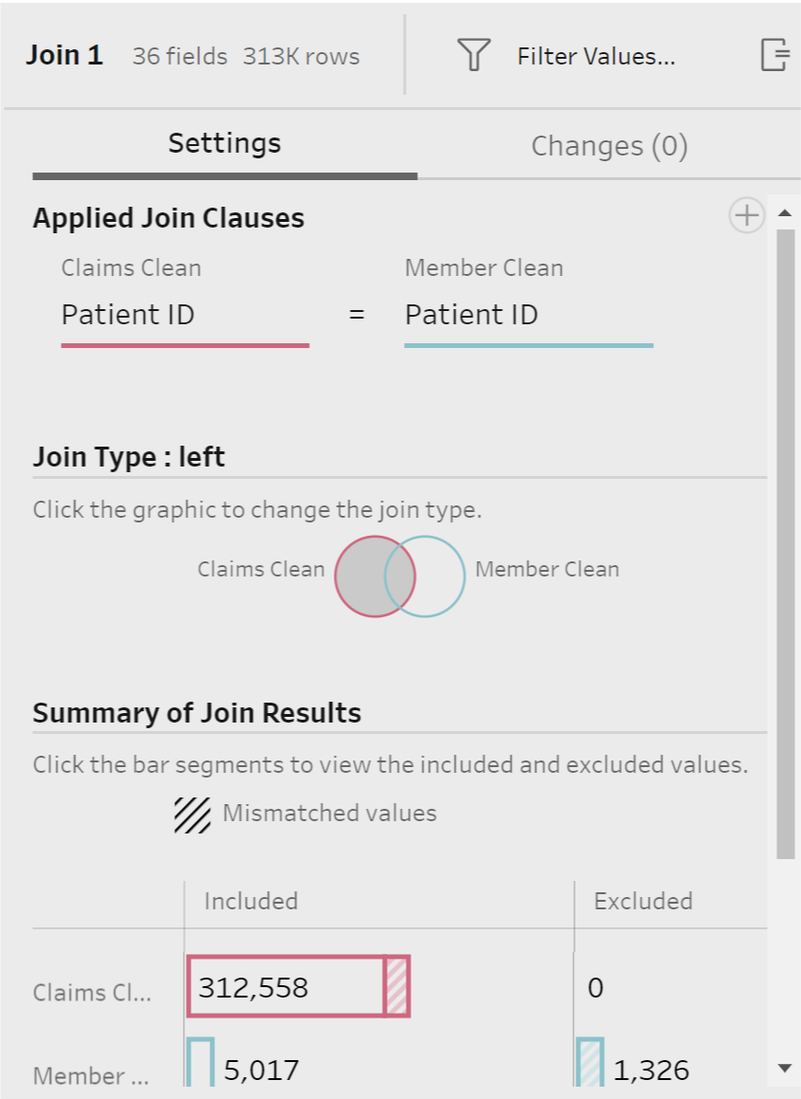 | Joining the Datasets:  Now that Member Policy is cleaned we can join it to our claims data to match our members to their policy information.  - Drag Member Info Clean directly on top of Claims Clean step. Select Join in pop-up orange box.  - Change to a Left Join
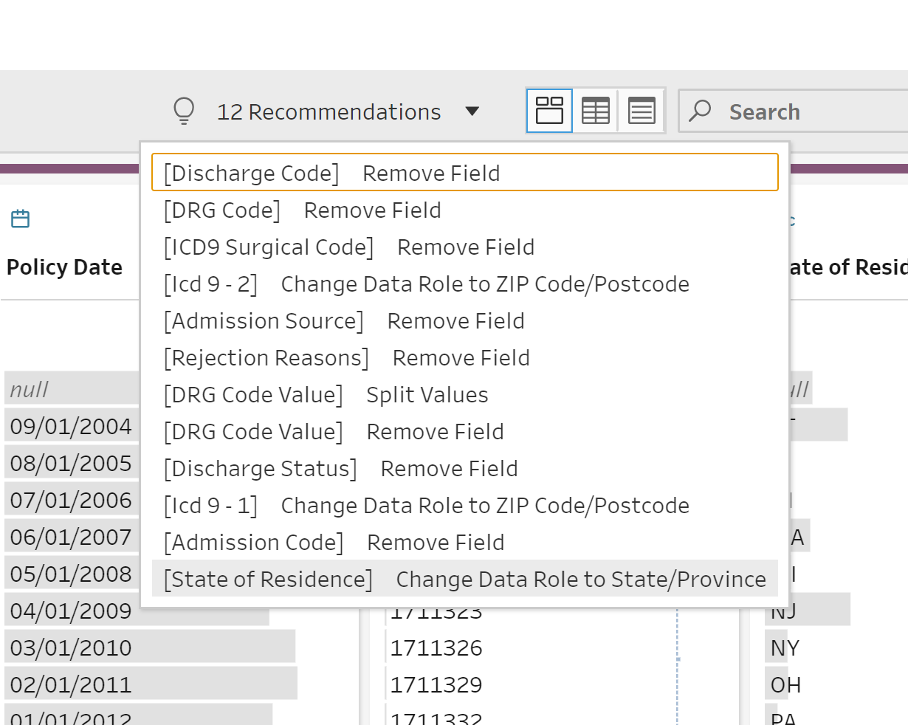 | Final Clean Step  - For good measure, we’ll add one more Clean step to ensure we caught everything.  - Select on the Light Bulb- Tableau’s Recommendations  - Select the last option [State of Residence] to a geographic field  - Remove duplicate Patient ID-1 field
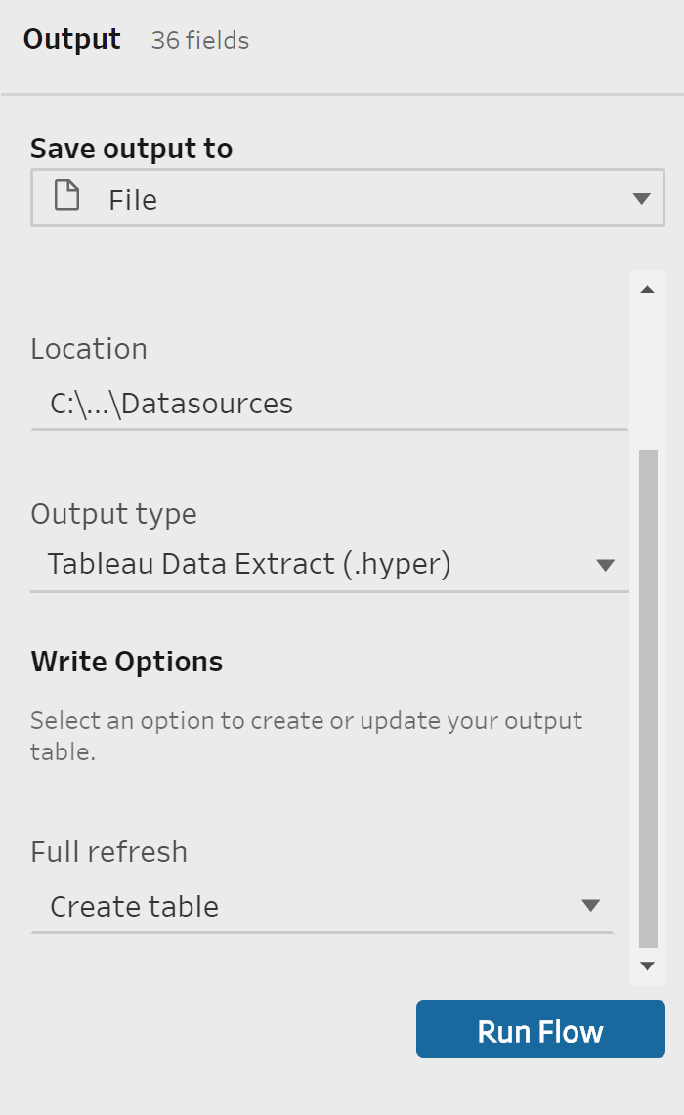 | ADD AN OUTPUT & SCHEDULE YOUR FLOW:  Now that we’ve finished integrating and cleaning our data, we are ready to run the flow and decide how to output this data.  - Select Add an Output -> File -> Name Flow ->Select .hyper or .csv  - Run Flow  - Connect to your file in Tableau Desktop  Now we need to schedule this Flow to refresh with Prep Conductor & How to access Prep in the Browser (2020.4).  DEMO TIME

